IDEATION PHASE
Brainstorm & Idea Prioritization Template

DATE | 31 January 2025
TEAM ID | LTVIP2025TMID30643
PROJECT NAME | Visualization tools for electric vehicles charge and range analysis
MAXIMUM MARKS | 2 marks

Brainstorm & Idea Prioritization Template:

This visualization tool is designed to help electric vehicle users clearly understand, predict, and optimize battery charge and driving range through intuitive, data-driven visuals. It transforms complex energy data—such as battery state, consumption patterns, terrain, weather, and charging behavior—into easy-to-interpret maps, charts, and interactive simulations.

Reference: https://www.mural.co/templates/brainstorm-and-idea-prioritization

Step-1: Team Gathering, Collaboration and Select the Problem Statement:
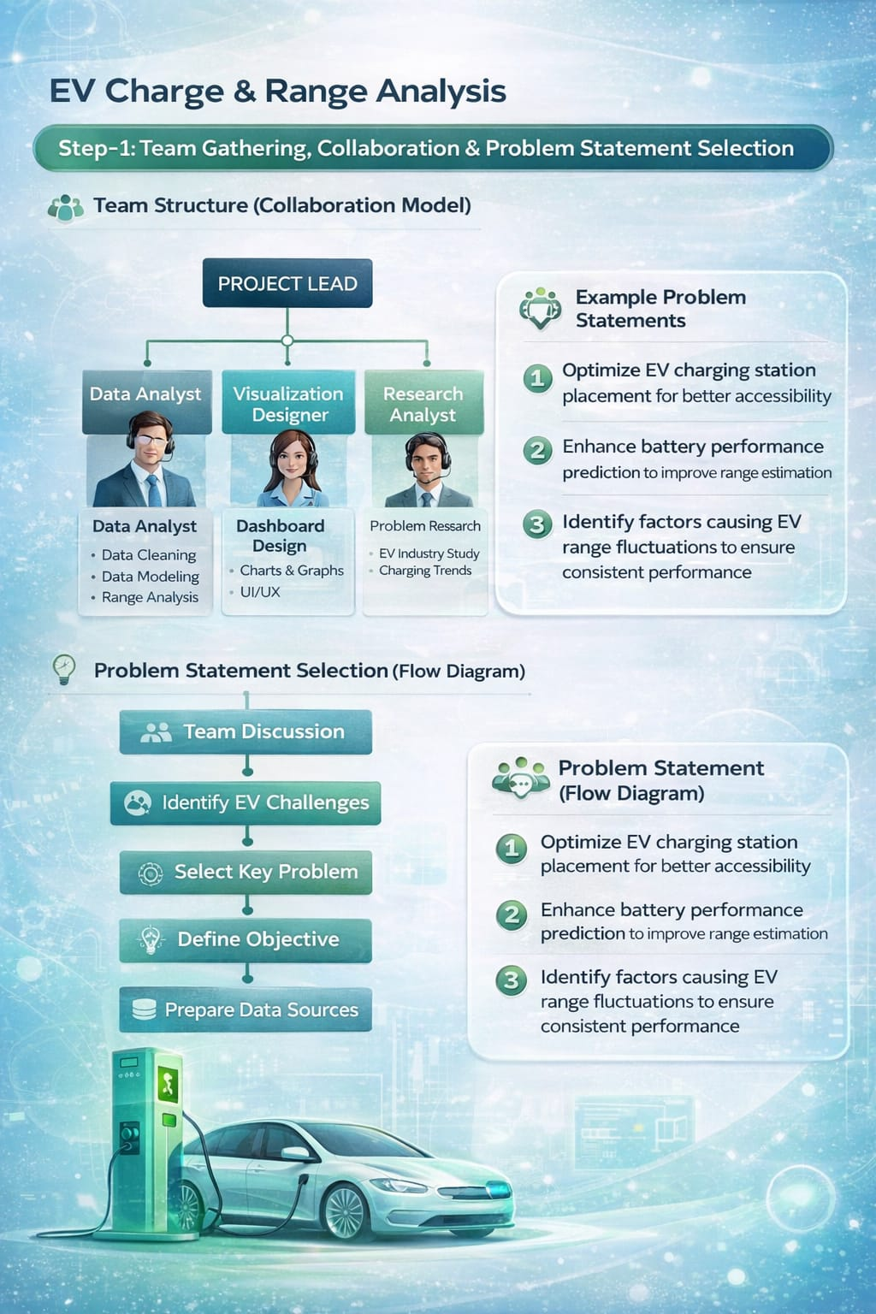
Step-2: Brainstorm, Idea Listing and Grouping
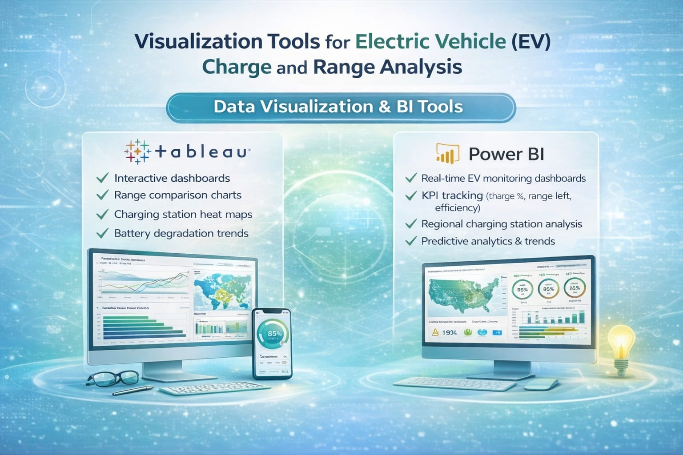

Step-3: Idea Prioritization
